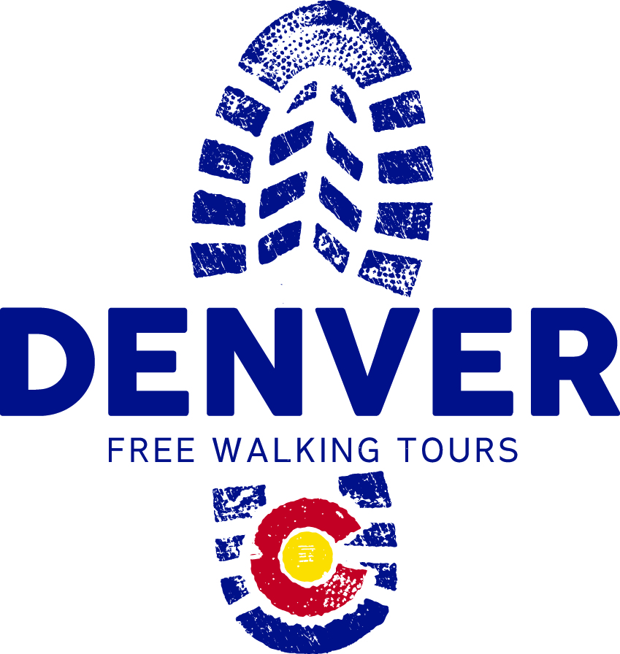

Tour Guide Intern Opportunity
2016
Denver Walking Tours
www.walkingtoursdenver.com
This internship opportunity is paid according to the following schedule:
- Paid training and professional development, $12/hour.
- Free morning tours - Tips only for daily free 10 am walking tours less a $2/participant shared cost fee to cover marketing, advertising, professional development and insurance for each of our guides. Market research and our data from the previous year shows that the average tip is $5-10+/person. We average about 10 clients per tour, meaning that you will make a minimum of $50+ in tips for two hours work.
- Private tours - $50-70 for our 2 hour tours, depending on the number of clients.
- No benefits are available.
Interns may be (but do not need to be) in school and will receive course credit for the internship. If in school, interns with the following degree focus areas are especially encouraged to apply:
- History
- Teaching
- Hospitality
- Customer Service/HR
Timing: Flexible start and end dates with a minimum commitment of five months.
Duties: If you think that you have the knowledge, the skills, and the passion to learn how to lead visitors on meaningful and fun excursions through the streets and structures of downtown Denver and make them fall in love with this city as much as you are, we want to meet you!
We currently do not have any full-time positions. All of our guides are able to lead tours 1-4 days each week (about 2-3 hours a day, including commuting time) Tour Guides lead free daily tours at 10:00 am and private tours mornings, afternoons, and evenings.
The Tour Guide’s responsibilities include, but are not limited to:
- Conducting walking tours in downtown Denver along a 1.8 mile route that begins in Civic Center Park and ends near Coors Field, passing 13+ downtown local attractions along the route. The tour takes approximately two hours.
- Share historically accurate information/facts (from provided talking points) in an entertaining, lively and engaging manner. Facts may include Denver “firsts,” conmen, ghosts, grand and other “less savory” pieces, moments, and events of Denver history that will keep customers entertained and intrigued.
- Do observational research by taking part in other Denver Walking Tour Guides' tours in order to gain insight into the roles and responsibilities of a tour guide and attributes of an excellent tour guide.
- Attend debriefing meetings and/or participate in conference calls with owners, as needed.
- Follow an established paid training and paid professional development work plan.
- Take photos of each tour group which must include all clients and posting photo to DWT Facebook page within 24 hours of tour.
We are looking for interns who meet most of the following criteria:
- Knowledgeable about the city's culture and history (full paid training with tour talking points provided)
- Previous leadership experience
- Previous group management experience
- Passion for either leading tours or working with groups of people of all ages
- Performance experience (stage, screen, music, improv, comedy, etc)
- Teaching experience
- Tourism or travel industry experience
- Madly in love with Denver
- Availability to lead 10:00 am group walking tours 1-4 days per week
Required Knowledge, Skills and Abilities:
- Must be able to read, write, and speak fluent English and be able to project voice so that a large group of people can clearly hear at all times
- Ability to complete work by established deadlines
- Able to lead 10:00 am tours and be available for occasional night and weekend conference calls and meetings, as needed
- Superb group management skills
- Dedication to outstanding customer service
- Excellent speaking skills, with an ability to relay information to groups in a fun, unique way
- Knowledge of Denver history, architecture, and key downtown Denver tourist destinations is preferred
- Task oriented and highly motivated
- Reliable and timely
- High integrity and confidence
- Ability to work both independently and as a team member
- Exceptional personality
- Must be able to memorize talking points and relay them in an entertaining manner
- Ability to stand/walk for 2+ hours, work safely, and lead groups safely through downtown Denver

Qualifications:
- High School graduate or equivalent is required
- Access to internet and computer
- Knowledge of Microsoft Word, Facebook, and Google Drive for document sharing/collaboration
- Interest and/or knowledge of Denver history is preferred
- Prior performance, teaching, or group leadership experience is preferred

If you are an interested candidate, please send a cover letter, resume, and answers to the application questions on next page to Jill Collins: info@denverfreewalkingtours.com

Tour Guide Internship Application Questions
Please submit an application that answers all of the following questions:

- First & Last Name:
- Email:
- How long have you lived in Denver?
- Do you speak any languages, other than English, fluently?
- Tell us about any work experience that you have that pertains to this job:
- What type of “Stage Experience” do you have (theatre, improv, music, dance, street performance, teaching, etc.)?
- What type of teaching experience do you have (camp counselor, piano teacher, led a workshop, taught a class, etc.)?
- Describe where you would go and what you would do to show a visiting friend the best 24 hours ever in Denver. Your friend also shares that he/she doesn’t want to do only “touristy” things in the 24 hours they are visiting.
- Tell us about a significant leadership experience.
- What traits and/or strengths do you like most about yourself?
- What do you think is the most important quality or attribute of an amazing tour guide and why?
- Why should we hire you for this position?
- What is your year-round weekly availability to lead tours at 10:00 am (what days work, what days do not)?
- How many days each week would you like to lead tours?
- Last words – please add anything else you want to tell us!

